To get Tibet2 working on a localhost, just check it out and prepare it like almost every other Ibis.

There’s only one thing different, which you have to do once during setup. Application Claim, a part of Tibet2 is working with a pregenerated xml-file which contains all TibcoQueues and the belonging BusinessDomains and ServletApplicationNames. This file is called “allTibcoQueues.xml”.

To generate this file follow the next steps:

1. Setup and prepare your environment for Tibet2 on localhost like almost every other Ibis.
2. When it’s working, go to test a pipeline (<http://localhost/ija_tibet2/rest/testPipeLine>)
3. Select adapter “StoreShowTibcoQueue**s**ToFileSystem” (make sure your selection is “queues” and not “queue”).
4. Put in “Message” a random text, for example “z”
5. Press “send”
6. If everything is fine, you’ll get a file location where “allTibcoQueues.xml” is stored. For example: C:\Users\M64A488\Temp\allTibcoQueues.xml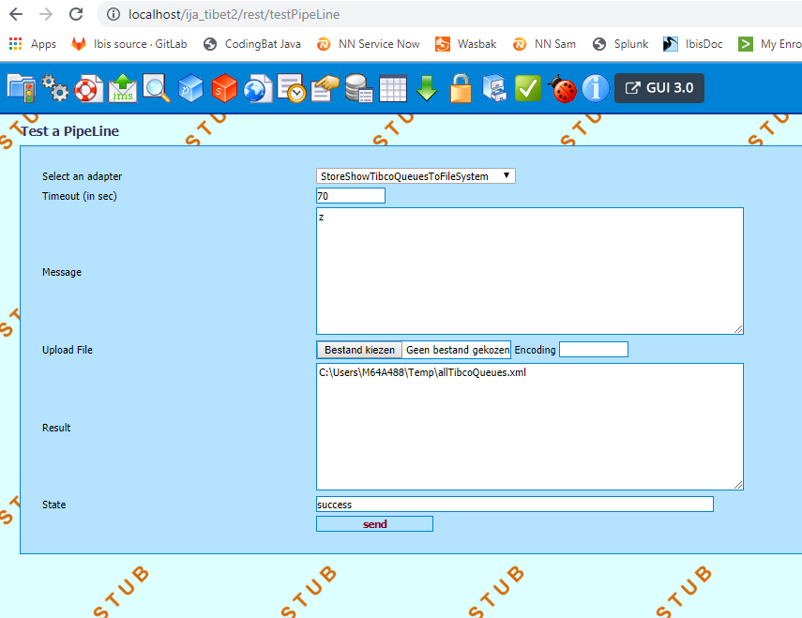

If everything is fine, it looks like this:

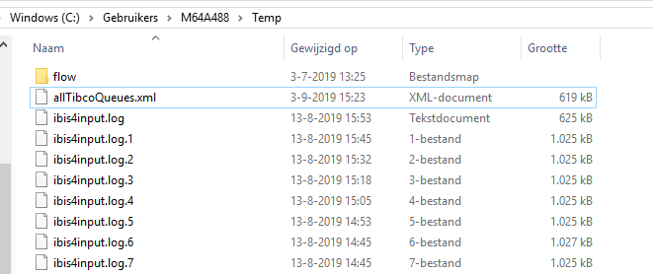

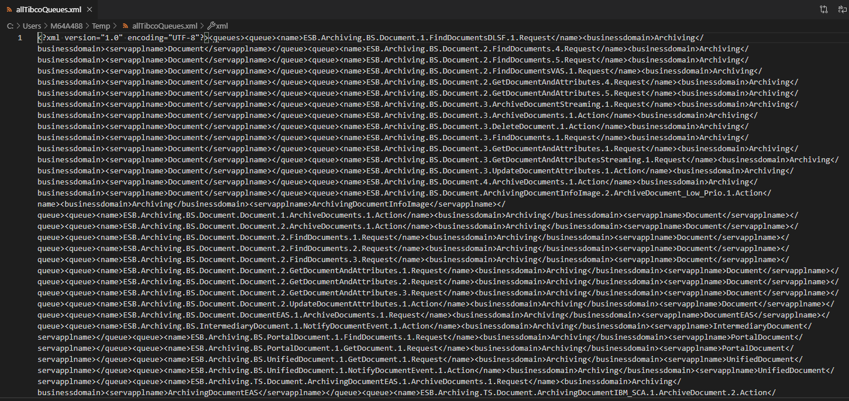

You’re ready now. You can use Application Claim local by visiting the next url: <http://localhost/ija_tibet2/rest/claimapp>